**Assignment: Subscribe to my Webpage!**

TLDR: Create a webpage form that accepts a first name, last name, and selection of preferred contact. When a button or link is pressed, the information the user entered will be displayed on the page.

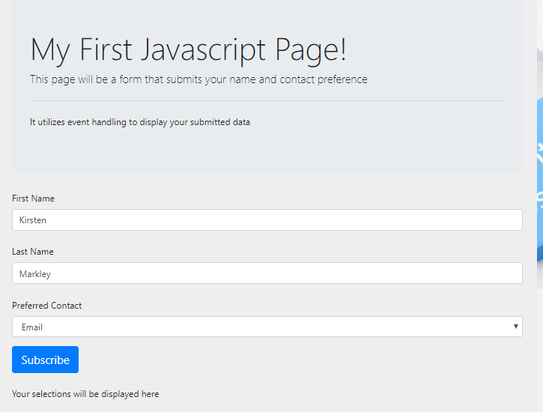 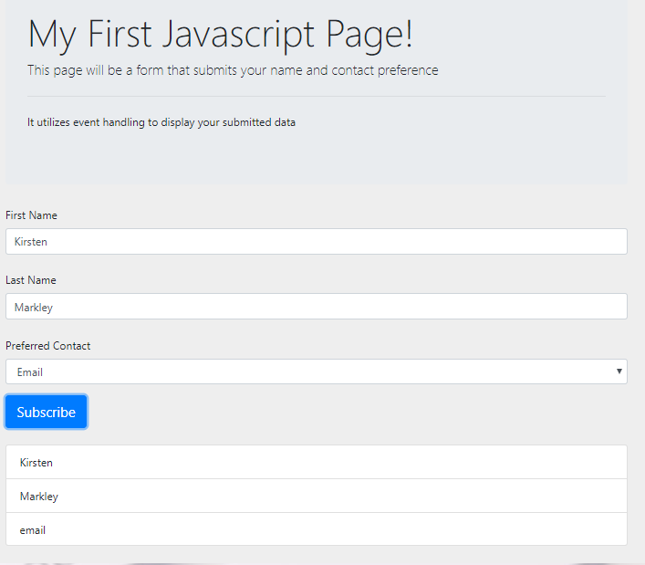

*** Refer to the CIS Plagiarism Policy! You must use the concepts covered in my video, or within the first chapter of the book. Otherwise, you will get a zero *****

* Look up on the wise Internet for the use of the *innerHTML* property. You will use this property to display the items the user entered in the form.
* Create a form with two text boxes and a drop down
  + The text boxes are for the person’s first name and last name
  + The drop down is for the user to select their preferred method of contact (email, phone, etc)
    - The id should be within the **<select id=”theIDName”>**
    - The value should be within the   
      **<option value=”email”>Email</option>**
    - When you use   
      **document.getElementById(‘theIDName’).value** it will return the value of the option selected.
  + Be sure each element has a unique id
* Create a <div> with a unique id. You will use the innerHTML property of this div to display the data entered in the form.
* Create a SUBSCRIBE element for the user to click. This can be an input type **button**  or it can be an <a> tag. *(hint: do not use a type=”submit” as this will cause problems we will understand later)*
  + Add an *onclick*  event to the subscribe link
    - Get the values of all three form fields using document.getElementById(‘uniqueID’).value
    - concatenate them and display the final string in the div’s innerHTML  
      eg:   
      **<input type=”button” onclick = “document.getElementById(‘divName’).innerHTML = document.getElementById(‘fName’).value” + *concatenate more here* >**
* Finally after this is all working – make it look professional. A plain white webpage will get you a minimum of a “C” grade. I would encourage you to use Bootstrap as it is an industry standard. But it is not a requirement.